Network Diagram

( ! ) There is no information in the final project regarding the current network topology.

During our online research, we discovered that:
4Geeks Academy has between 51 and 200 employees. Indeed.com and LinkedIn both report this range for the company's employee headcount.

Link: https://www.indeed.com/cmp/4geeks-Academy
Link: https://www.linkedin.com/school/4geeksacademy/about/

We will create a network diagram for environments with 51 and 200 employees.

This network must have:

( 1 ) Firewall: Essential Protection for Network Security

( 2 ) Demilitarized Zone (DMZ): The purpose of a DMZ is to add a layer of security to an organization's internal network, protecting it from unauthorized access.

Moreover, the use of advanced cybersecurity tools and technologies is strongly recommended:
IDS:
Intrusion Detection System
Detects malicious activity
Monitors: Network traffic

IPS:
Intrusion Prevention System
Detects and blocks threats
Monitors: Network traffic

NDR:
Network Detection and Response
Uses AI/behavioral analytics to detect threats across network
Monitors: Network

EDR:
Endpoint Detection and Response
Detects and responds to threats on individual devices (endpoints)
Monitors: Laptops, servers, etc.

SIEM:
Security Information and Event Management
Aggregates and analyzes security logs and events for detection, alerts, and compliance
Monitors: Logs from multiple sources

DLP:
Data Loss Prevention
Prevents unauthorized sharing or leakage of sensitive data
Monitors: Files, emails, USB, cloud

Using a layered combination of cybersecurity tools like IDS, IPS, NDR, EDR, SIEM, and DLP significantly strengthens an organization’s security posture by enabling real-time threat detection, response, and data protection while supporting compliance and operational efficiency.

Tree Topology:

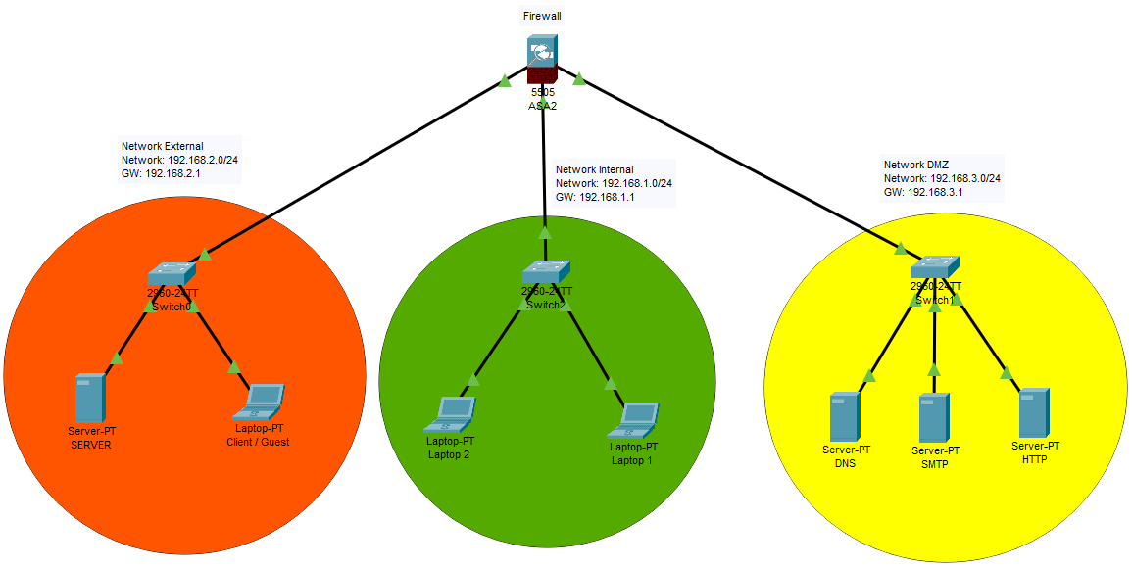
Key Benefits of Using a DMZ Network:

Enhanced Security
Secure External Access
Improved Network Segmentation
Granular Firewall Control
Support for Security Monitoring and Logging
Reduced Attack Surface

